SIMATS ENGINEERING (SAVEETHA SCHOOL OF ENGINEERING)
Department of Computer Science and Engineering
ASSESSMENT TOOL 3 – Comparative Analysis

Course Code: | CSA06 | Course Title: | Design and Analysis of Algorithms
CO Assessed: | CO4: Articulation (BL4, BL5) | Assessment: | Assessment Tool 3 – Comparative Analysis
Weightage: | 10% of CIA | Total Marks: | 100
CO4 Statement: | Solve optimization problems using dynamic programming and greedy strategies.
Student Name: | Rafeez ahamed SI | Reg. No.: | 192524078
Section / Batch: | 2025 | Date: | 22-08-2026
Instructions to Students

- Answer the following question. Total Marks: 100.
- Analyze the given questions thoroughly before answering.
- Compare multiple aspects such as methods, results, advantages, and limitations clearly.
- Critically evaluate the strengths, weaknesses, and implications with proper justification.
- Present meaningful insights, interpretations, and well-supported conclusions from the comparisons.

Question Type | Focus Area | Questions
Comparative Analysis | Comparative analysis of Dynamic Programming and Greedy algorithms for optimization problems. | Q1

SECTION A – Comparative Analysis

Code of Conduct
I (Name / Reg No) certify that this submission is my original work and that I have adhered to the guidelines specified for this assessment. I understand that any violation of academic integrity rules will result in disciplinary action.
Signature of the Student:

RUBRICS FOR CALCULATION

Comparative Analysis
Criteria | Weightage | Level 4 (Exemplary) | Level 3 (Proficient) | Level 2 (Developing) | Level 1 (Beginning)
Selection of Studies/Parameters | 20% | Selects highly relevant and diverse studies with  well-defined comparison parameters | Selects relevant studies with minor  gaps in parameter definition | Limited or partially  relevant selection | Poor or inappropriate  selection of studies
Comparison & Differentiation | 25% | Clearly compares multiple aspects (methods, results, limitations) with strong differentiation | Good comparison with minor gaps | Basic comparison  with limited depth | No clear comparison;  mostly descriptive
Critical Evaluation | 25% | Critically evaluates strengths, weaknesses, and implications with strong justification | Provides  evaluation with some justification | Limited  evaluation; lacks depth | No critical  evaluation provided
Synthesis & Insight Generation | 20% | Generates meaningful  insights and conclusions from comparisons | Some insights  derived from comparison | Limited or unclear insights | No insights generated
Clarity | 10% | Information is clearly presented (tables/figures) with logical structure | Generally clear with minor issues | Presentation lacks clarity or structure | Poor presentation and difficult to understand

Marks Evaluation:
Criteria | Wt. | Level 4 – Exemplary | Level 3 – Proficient | Level 2 – Developing | Level 1 – Beginning
Selection of Studies/Parameters | 20%
Comparison & Differentiation | 25%
Critical Evaluation | 25%
Synthesis & Insight Generation | 20%
Clarity | 10%
Total Marks (100):

Faculty In-charge | Course Coordinator | Head of Department
Name: | Name: | Name:
Signature: | Signature: | Signature:
Date: | Date: | Date:

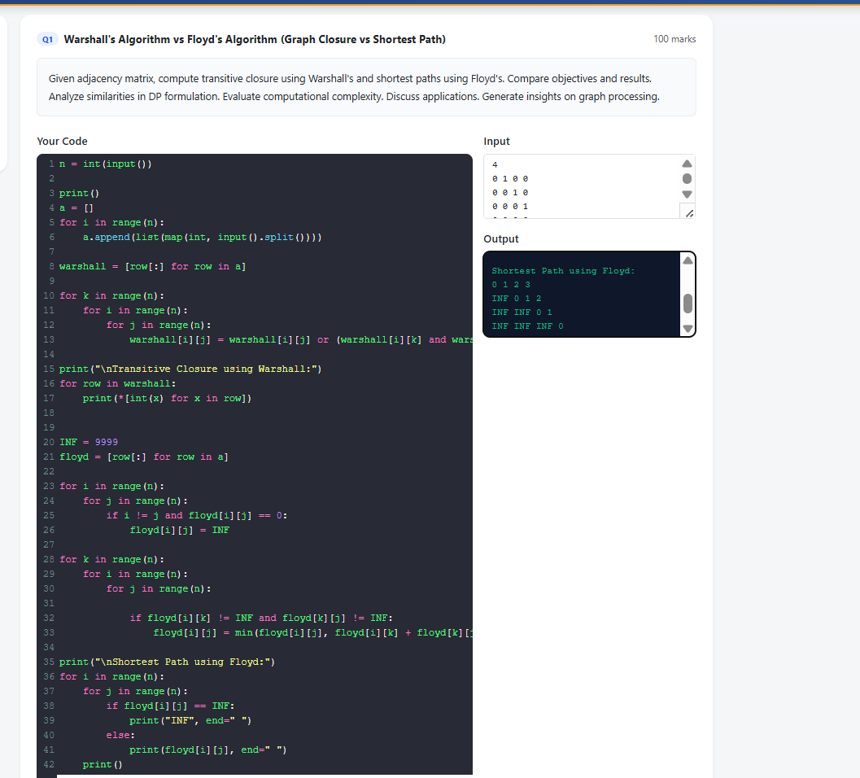

Comparative Analysis: Warshall's vs. Floyd's Algorithm
1. Objectives
- Warshall's Algorithm: The primary objective is to compute the transitive closure of a directed graph. It determines whether a path exists between any two vertices (i, j) using Boolean logic.
- Floyd's Algorithm: The primary objective is to find the all-pairs shortest paths. It calculates the minimum weight/distance required to travel between any two vertices (i, j) using additive arithmetic.
2. Comparison of Results
- Warshall's Result: Produces a binary matrix where a 1 indicates reachability (a path exists) and a 0 indicates no path exists.
- Floyd's Result: Produces a weight matrix where each entry represents the actual minimum distance between vertices. If no path exists, the value is represented as infinity (∞).
3. Dynamic Programming (DP) Formulation
Both algorithms utilize the Dynamic Programming paradigm by breaking the problem into subproblems based on intermediate vertices.
- Similarity: Both use the concept of an intermediate vertex k to update the state of the matrix. They both iterate through k from 1 to n, building up the solution incrementally.
- Difference in Relation:
  - Warshall uses the logical OR and AND operators: R^((k)) [ i, j ]= R^((k − 1)) [ i, j ]∨ (R^((k − 1)) [ i, k ]∧ R^((k − 1)) [ k, j ]).
  - Floyd uses the min function and addition: D^((k)) [ i, j ]= min (D^((k − 1)) [ i, j ], D^((k − 1)) [ i, k ]+ D^((k − 1)) [ k, j ]).

4. Computational Complexity
- Time Complexity: Both algorithms have a time complexity of O(n^3) due to the three nested loops iterating over the number of vertices n.
- Space Complexity: Both algorithms have a space complexity of O(n^2) to store the adjacency/distance matrix.
5. Applications
- Warshall's: Useful in connectivity testing, determining reachability in networks, and simplifying complex dependency graphs.
- Floyd's: Essential in routing protocols (like finding shortest paths in a network), GPS navigation systems, and any scenario involving weighted graphs where distance minimization is required.

